

**Computing Intent, Implementation and Impact**

**Intent**

At Old Park School we passionately believe that Computing has the potential to empower pupils with SEND and transform their lives. With the right blend of progressive, imaginative planning, exposure to a broad range of tools and technologies and comprehensive support it is possible that all pupils can fulfil their potential – in computing and throughout the curriculum.

Computing and Information Technology are essential tools for inclusion. They enable pupils with SEND, whatever their needs, to use technology purposefully in ways that make the wider curriculum accessible, empower those with communication difficulties to engage with others and to fully include everyone in activities and learning.

Our Computing curriculum covers the breadth of the National Curriculum and focuses on a progression of skills in digital literacy, computer science, information technology and online safety to ensure that children can grow in confidence in safely using, as well as understanding, technology. This includes knowledge, skills, key vocabulary and concepts adapted from the national curriculum These strands are revisited repeatedly through a range of themes during pupil’s time in school to ensure the learning is embedded and skills are successfully developed. The 5 pathways follow units and schemes of work that follow a cycle and coherent sequence of skills and knowledge, which leads to the expected end of key stage one standards in computing. Our intention is that Computing also supports children’s creativity and cross curricular learning to engage pupils and enrich their experiences in school.

Pupils working in Pathway 1 will have multisensory Computing experiences, Pathway 2 pupils will experience early concepts of computing and Pathways 3, 4 and 5 will have subject specific computing delivery. For pupils working within pathway 1 and 2, we focus on their developing skills for independence and communication. Primary pupils focus on equipment that engages them at play level and as we move on through school, we focus more on skills preparing for adulthood, Pupils are assessed using the engagement model. Old Park developmental scales 5 – 14 provide a coherently sequenced skills and knowledge progression for subject specific learning; Scale 14 includes the expected outcomes end of key stage one. We are setting expectations for pathway 5 are ensured by including aspects of the key stage 2 computing curriculum within old park scale 15. Pupils are encouraged to develop their communication skills and use and extend their vocabulary for Computing elements that are pertinent to their own learning needs. Opportunities are provided for pupils to understand how Computing can be used to towards their communication and independence skills which in turn support preparing our young people for adulthood and life after school. The computing curriculum will evolve and develop in line with modern technology to enable our pupils to have the skills and knowledge to help them towards independence in the modern world.

For many of our Pupils Computing/ICT skills are used throughout the day in cross curricular learning but also some pupils use AAC for their communication throughout the day.

**Implementation (Long Term Sequence of Learning)**

Computing and Information Communication Technology is an integral part of the provision delivered throughout school daily. Pupils are given ongoing opportunities to interact with equipment and software as part of planned routines for example, during Good Morning communication and interaction sessions. The skills of Computing may also be taught cross circularly throughout the week, particularly in English or in communication focused lessons. In addition, Pathway 1 pupils have Multisensory Computing and Pathway 2 have Early Computing lessons timetabled. Pupils will be working towards specific skills and targets for their ability. In pathway 1 and 2 pupils will be using computing technology including but not limited to; the magic carpet, eye gaze, iPad, interactive whiteboards, cause and effect toys and using switch operated toys and devices.

Pathway 3,4 and 5 pupils have subject specific discrete Computing sessions which are taught with a particular focus on acquiring, developing, and applying identified knowledge, skills and concepts.

The schemes of work at Old Park School are based around the Sheffield SEND scheme, with context given to each unit through the termly theme which could be delivered in a cross curricular style.

All pupils will work at the appropriate level; our curriculum is designed to cyclical; pupils may visit units over the cycles with different topics. This enables pupils to revisit skills and learning, potentially developing their skills, knowledge and embedding prior learning. Skills knowledge and key vocabulary are included in each unit of work to enable Teachers to plan and focus lessons on the relevant skills to develop for each pupil.

|  |  |  |  |  |  |
| --- | --- | --- | --- | --- | --- |
| **Computing Cycle A** |  | **Primary** | | **Secondary** | |
|  | **Half Term 1** | **Half Term 2** | **Half Term 1** | **Half Term 2** |
| **Autumn**  Movers and Shakers | Pathway 1 and 2  Focus skills – activities based on theme or pupil interest | Exploring frequently used computing equipment i.e., IWB, iPad, eye gaze and magic | Use a touch screen or switch to activate number songs or activities i.e., helpkidz learn | Make something happen on the internet i.e., play a video or search for a topic | To use technology to make their choice or preference known |
| Pathway 3,4 & 5  Units from Sheffield SEND Scheme of work. | Using Technology  1a Everyday Technology | Communication – Data  3a Counting (ext. 3b Sorting) | Using Technology  1b What is the internet? | Communication – Data  3c Pictograms and Charts (ext. 3d Branching Databases) |
| **Spring**  Special stories | Pathway 1 and2  Focus skills – activities based on theme or pupil interest | Focus on cause and effect i.e., switch toys | Focus on using technology to choose what is next in a familiar sequence or identify what they can see | Explore making things move through controls i.e., remote control car or switch toys | Explore cause and effect early programming using the magic carpet |
| Pathway 3,4 & 5  Units from Sheffield SEND Scheme of work. | Programming and Algorithms  4a We Control Technology | Programming and Algorithms  4b Sequencing Instructions (ext. 4c Finding Patterns | Programming and Algorithms  4d Beebots | Programming and Algorithms  4e ScratchJr |
| **Summer**  Treasure Island | Pathway 1 and2  Focus skills – activities based on theme or pupil interest | Use technology to make marks and digital art through touch screens based the topic | Use technology to create cause music and sounds based on the topic | Use a range of devices to take photos based on the topic | Use a range of devices to record videos based on the topic |
| Pathway 3,4 & 5  Units from Sheffield SEND Scheme of work. | Communication – Media  2a Digital Art (ext. 2e eBook) | Communication – Media  2b Sound Music (ext. 2e eBook) | Communication – Media  2c Photographs  (ext. Animation) | Communication – Media  2d Films (ext. Animation) |

*Opportunities to embed unit 1c Key Skills to run throughout. All sessions to be underpinned by appropriate online safety messages.

|  |  |  |  |  |  |
| --- | --- | --- | --- | --- | --- |
| **Computing Cycle B** |  | **Primary** | | **Secondary** | |
|  | **Half Term 1** | **Half Term 2** | **Half Term 1** | **Half Term 2** |
| **Autumn**  Time Travellers | Pathway 1 and 2  Focus skills – activities based on theme or pupil interest | Exploring frequently used computing equipment i.e., IWB, iPad, eye gaze and magic | Use a touch screen or switch to activate number songs or activities i.e., helpkidz learn | Make something happen on the internet i.e., play a video or search for a topic | To use technology to make their choice or preference known |
| Pathway 3,4 & 5  Units from Sheffield SEND Scheme of work. | Using Technology  1a Everyday Technology | Communication – Data  3a Counting (ext. 3b Sorting) | Using Technology  1b What is the internet? | Communication – Data  3c Pictograms and Charts (ext. 3d Branching Databases) |
| **Spring**  Special Places, Special Times | Pathway 1 and2  Focus skills – activities based on theme or pupil interest | Focus on cause and effect i.e., switch toys | Focus on using technology to choose what is next in a familiar sequence or identify what they can see | Explore making things move through controls i.e., remote control car or switch toys | Explore cause and effect early programming using the magic carpet |
| Pathway 3,4 & 5  Units from Sheffield SEND Scheme of work. | Programming and Algorithms  4a We Control Technology | Programming and Algorithms  4b Sequencing Instructions (ext. 4c Finding Patterns | Programming and Algorithms  4d Beebots | Programming and Algorithms  4d ScratchJr |
| **Summer**  Dark Nights, Bright Lights | Pathway 1 and2  Focus skills – activities based on theme or pupil interest | Use technology to make marks and digital art through touch screens based the topic | Use technology to create cause music and sounds based on the topic | Use a range of devices to take photos based on the topic | Use a range of devices to record videos based on the topic |
| Pathway 3,4 & 5  Units from Sheffield SEND Scheme of work. | Communication – Media  2a Digital Art (ext. 2e eBook) | Communication – Media  2b Sound Music (ext. 2e eBook) | Communication – Media  2c Photographs  (ext. Animation) | Communication – Media  2d Films (ext. Animation) |

*Opportunities to embed unit 1c Key Skills to run throughout. All sessions to be underpinned by appropriate online safety messages.

|  |  |  |  |  |  |
| --- | --- | --- | --- | --- | --- |
| **Computing Cycle C** |  | **Primary** | | **Secondary** | |
|  | **Half Term 1** | **Half Term 2** | **Half Term 1** | **Half Term 2** |
| **Autumn**  Bostin Black Country | Pathway 1 and 2  Focus skills – activities based on theme or pupil interest | Exploring frequently used computing equipment i.e., IWB, iPad, eye gaze and magic | Use a touch screen or switch to activate number songs or activities i.e., helpkidz learn | Make something happen on the internet i.e., play a video or search for a topic | To use technology to make their choice or preference known |
| Pathway 3,4 & 5  Units from Sheffield SEND Scheme of work. | Using Technology  1a Everyday Technology | Communication – Data  3a Counting (ext. 3b Sorting) | Using Technology  1b What is the internet? | Communication – Data  3c Pictograms and Charts (ext. 3d Branching Databases) |
| **Spring**  Special People, Special Symbols | Pathway 1 and2  Focus skills – activities based on theme or pupil interest | Focus on cause and effect i.e., switch toys | Focus on using technology to choose what is next in a familiar sequence or identify what they can see | Explore making things move through controls i.e., remote control car or switch toys | Explore cause and effect early programming using the magic carpet |
| Pathway 3,4 & 5  Units from Sheffield SEND Scheme of work. | Programming and Algorithms  4a We Control Technology | Programming and Algorithms  4b Sequencing Instructions (ext. 4c Finding Patterns | Programming and Algorithms  4d Beebots | Programming and Algorithms  4d ScratchJr |
| **Summer**  Restless Earth | Pathway 1 and2  Focus skills – activities based on theme or pupil interest | Use technology to make marks and digital art through touch screens based the topic | Use technology to create cause music and sounds based on the topic | Use a range of devices to take photos based on the topic | Use a range of devices to record videos based on the topic |
| Pathway 3,4 & 5  Units from Sheffield SEND Scheme of work. | Communication – Media  2a Digital Art (ext. 2e eBook) | Communication – Media  2b Sound Music (ext. 2e eBook) | Communication – Media  2c Photographs  (ext. Animation) | Communication – Media  2d Films (ext. Animation) |

*Opportunities to embed unit 1c Key Skills to run throughout. All sessions to be underpinned by appropriate online safety messages.

For Primary and secondary students at pathway 1 and 2 – Use the themes of each topic to develop the following:

Experiences using computing related to the topic.

Choice making

Cause and effect

Communication

And fun

However, if this is not possible or the student is showing an interest using their own motivator or hobby, then follow their interest to develop engagement and interaction.  Use eye gaze and switch development documents in ICT folder to support pupils in setting realistic targets and motivating/engaging activities in non-subject specific learning.

Always remember the following: **Access, Include, Engage, Empower**

The focus skills link with units of work from the Sheffield SEND scheme of work taught in pathway 3, 4 & 5; these skills can be used as a focus for activities for the half term and ensure pupils in pathways 1 & 2 are receiving a broad and balanced curriculum covering all areas within the national curriculum but taught at an appropriate skills level through multisensory learning. Teachers can also use the switch progression map documents to identify next steps for pupils. Pupils in Pathways 3, 4 & 5 are taught using the Sheffield SEND Schemes of work which have a coverage up to National curriculum year 1. Pupils who are excelling can also be stretched and challenged by accessing Kapow primary schemes of works which has coverage including the EYFS, Key stage 1 and Key stage 2.

Kapow:

Pupils who are excelling at computing can also work following Kapow units EYFS and key stage 1 in pathway 4 and the key stage 2 units in pathway 5. Pupils can move onto the Kapow units of work if it is felt that they are not being stretched or challenged with the Sheffield SEND units of work. If a teacher wants to move a pupil onto the Kapow Schemes of work this will done in consultation with The Computing Subject Co-ordinator and SLT and a record will be kept of the units covered to ensure that these pupils reach their full potential.

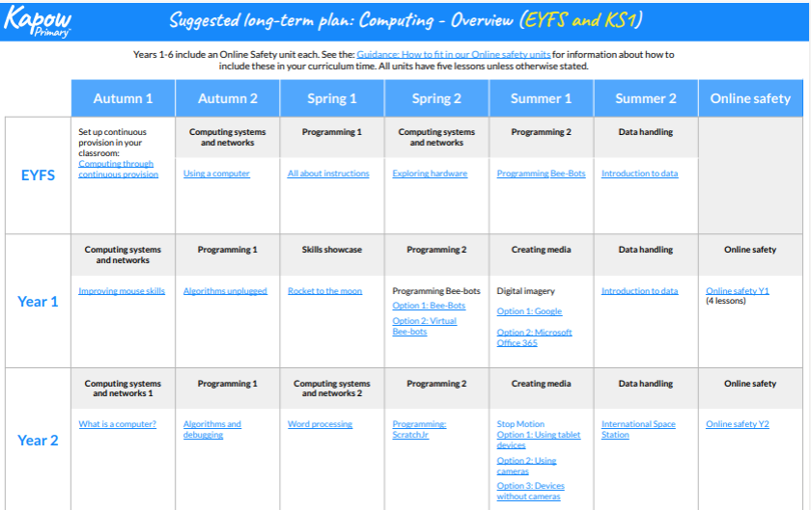

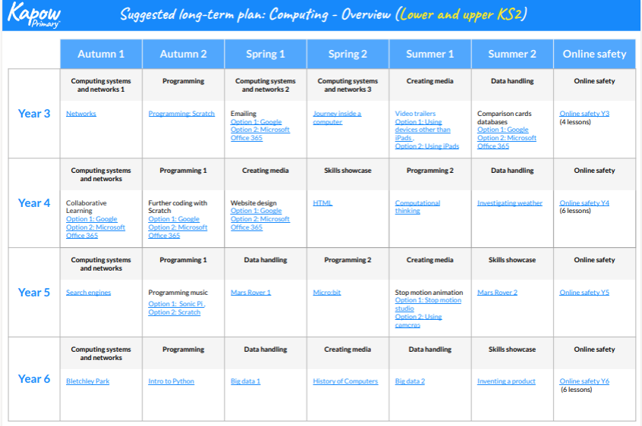

The Computing curriculum is written in consultation with and enhanced by the following -

|  |  |  |
| --- | --- | --- |
| **Pre-Subject Specific** | Pathway 1  Multi-sensory Foundations for Learning and Life  Pathway 2  Learning to Play, Learn and Live | Development Matters Birth to 3-year-olds  Reference only: OPS Scales 1-2, OPS Scales 3-4  Willow Dene Assessment Frameworks  Engagement Model, EHCP Personal Provision Plans |
| **Subject Specific** | Pathway 3  Roots | Skills, Concepts, Knowledge, Vocabulary linked to Computing KS1 Programmes of Study, National Curriculum England  Development Matters 3-4-year olds  OPS Scales 5-9: Subject roots  Sheffield SEND Scheme of Work  Engagement Model, EHCP Personal Provision Plans |
| **Subject Specific** | Pathway 4  Shoots | Skills, Concepts, Knowledge, Vocabulary linked to Computing KS1 Programmes of Study, National Curriculum England  Development Matters Reception age children into KS1 expectations  OPS Scales 10-14: Subject shoots  Sheffield SEND Scheme of Work  Kapow EYFS and key stage one units  Engagement Model, EHCP Personal Provision Plans |
| **Subject Specific** | Pathway 5  Blossom | Skills, Concepts, Knowledge, Vocabulary linked to Computing KS2 Programmes of Study, National Curriculum England  OPS Scales 15: Subject blossom  Kapow key stage 2 units  Engagement Model, EHCP Personal Provision Plans |

These documents can be used a guide for teachers for differentiation when planning for pupils in each pathway.

**Links to KS4/KS5 Projects**

Pupils following the 14-19 curriculum will develop their computing knowledge and understanding through a cycle of termly projects. In 14-19 the subject is referred to as ICT; because of the links to the OCR units and preparing for adulthood and life beyond Old Park School. Skills are taught using a primarily functional approach which is directly linked to preparation for adulthood. Computing skills are taught across the curriculum, but we have focused lesson to work on ICT – which is project based.

When studying computing or ICT at key stage 4, all pupils should be taught to:

* develop their capability, creativity and knowledge in computer science, digital media and information technology
* develop and apply their analytic, problem-solving, design, and computational thinking skills
* understand how changes in technology affect safety, including new ways to protect their online privacy and identity, and how to identify and report a range of concerns

This will be adapted to pupils’ abilities with a focus on functional skills that will be used to develop their communication, life skills, independent living skills and possibly skills for college or work-related learning.

OCR life and living ICT units is an accreditation for pupils based in 14-19. These units are adapted by the class teacher to meet the needs of pupils in their class. Completed during Projects. For example, during the project ‘Grand Designs’, pupils will have the opportunity to research, design and make using ICT Skills. They will be supported to research and plan a project, carry it out and then evaluate it.

Links have also been made between individual Long-Term sequences of Learning in Computing and Preparing for Adulthood and Key Stage 4 pupils also engage in Accredited learning specific to ICT through ASDAN transition challenges each term.

OCR life and living ICT units’ level 1 units F1 – F6 and level 2 Units F7-F11 will be covered in each project and lessons adapted to meet learners needs at all pathways. We use the Equals Essentials 14+ Curriculum and the units from this are mapped out in a two-year cycle below which will guide 14-19 teachers on the skills for each project. Differentiation guides can be found using the Old Park Scales in the Computing folder – these also show links with the National Curriculum.

14-19 LTSL

|  |  |  |  |
| --- | --- | --- | --- |
|  | Autumn Term | Spring Term | Summer Term |
| Cycle A  Projects | ‘#Whatsoccurring’ | ‘Scrapheap Challenge’ | ‘Old Park Presents’ |
| **Equals ICT units** | Keeping in touch  Social Networking  News Sharing | ICT in Enterprise  Design corporate images and logos | ICT and Creativity  Film making  Creating music and sounds |
| Cycle B  Projects | ‘JustGiving’ | ‘Ready Steady Cook’ | ‘Grand Designs’ |
| **Equals ICT units** | Keeping in touch  Exchanging information, email and texting | ICT for the future  Shopping: Online, in the community | ICT for Pleasure  Leisure And information  Digital photography |

Online safety

Online safety is a crucial element of our computing work and is taught to pupils at the appropriate level throughout the year. Pupils working within pathway 1 and 2 will be supported to identify potential risks and a taught about online safety through multisensory learning.

Pupils working at pathway 3 and beyond will learn all aspects of online safety and be encouraged to risk assess whether things are safe I.e. opening attachments and taught skills to help safeguard themselves.

The school uses filter and monitoring systems and pupils are taught that what they do online can be monitored within and out of school. The school website also has links for families about online safety and social media.

For more able students we will also introduce teaching them to question AI and deep fake; to check if content real/trustworthy.

**Impact**

Computing/ICT skills has strong cross curricular links to other subjects including Art using programs to create images, mathematics – data input and coding, English skills for writing and other communication methods including AAC and emails etc.

**Education Health Care Plans**

There are clear links that impact across all four areas of the EHCP within Computing.

* **Communication**: Computing as a subject is directly linked with communication, as the many of the technology-based resources used for computing can also be used for communication – such as iPad’s, switches, eye gaze for our pathway 1 and 2 learners and thinks like emails and instant messaging for pathway 3 and 4.
* **Cognition and Learning**: Computing also lends itself to cross curricular learning and can be a motivating tool for pupils to develop their skills and learning across all other subjects.
* **Social, Emotional and Mental Health**: Computing also has strong links with PSHE and there are many resources available that support pupils with their understanding of emotions and their own mental health available online.
* **Sensory and Physical:** Computing at old park is designed to develop pupils' physical skills both with gross and fine motor learning with equipment like the magic carpet and Interactive touch screens. Also, we use computing equipment and skills as part of our sensory diet

**Pre-Subject Specific Learners**

Pre–subject specific learners can engage with a sensory curriculum in which computing plays a major role.Pupils working at this level, benefit from a range of experiences and stimuli which supports to maximise their engagement and transfer learned skills over time, following the long-term structured sequence. This maximises the opportunity of these learners to respond, engage and communicate with the world around them and using technology to enhance their lives. This supports them to be active participants within the world that they are living. In line with their cognitive and physical development, pupils develop emergent communication of their awareness of an interaction, responding consistently to the same familiar people or resources around them, and moving towards or away from others to indicate basic wishes to interact, seek comfort, or reject touch from another. They begin to respond consistently to preferred stimuli and interact and use technology for learning, communication and fun. The long-term aims are to prepare are students for adulthood and how to incorporate technology into their lives.

**Subject Specific Learners**

Subject specific learners develop their use of technology and computing which plays a major role in communication and the skills can then be used cross circularly to help further develop their learning in other subjects. Pupils will develop skills during computing which will have an impact on their daily lives and can transfer to other subjects and skills for learning for life and beyond school. Computing skills also opens opportunities for hobbies and life beyond Old Park School.

**Preparation for Adulthood**

During an Old Park School stakeholder consultation on Post 19 hopes and aspirations across all pathways, a variety of responses were received. The following are addressed through the Computing curriculum.

* To be able to express my wants, needs, likes and dislikes using technology
* To be able to use technology to have fun
* To use technology to help me interact and engage with my wider community
* To be able to access technology to further an interest or hobby or for enjoyment
* To be able to use a device to support their choice making, whether daily or bigger decisions.
* To be able to use the internet and social media safely
* To be able to access online banking and bills and money management
* To be able to use technology to support independence (i.e. washing machine)
* To be able to stay safe online

Pupils will be able to engage with lessons using ICT, they will develop communication and interaction skills and develop skills in computing that will help them towards their independence or personal goals. Staff will continue to adapt the curriculum and skills taught as technology develops as this may enable more pupils to gain access to supported employment. Work related skills I.e. emailed work from teacher and work experience with ICT technician and work in school office –pupils supporting technology used in school I.e. power app for transport routes.

Teacher will have high expectations and quality evidence will be presented in a variety of forms, based on the age and individual’s needs. Pupils will gain confidence in using a variety of ICT equipment, with an emphasis on using it to help them communicate, interact and engage. We offer a broad curriculum following different focuses to help pupils use ICT to their fullest abilities, to enhance their learning, communication skills including choice making and interaction skills. Our overall aim is for pupils to be able to use ICT to help them make steps towards independence and lifelong learning. We aim for all pupils to use ICT to its full ability to support their communication, opportunities for work, independence and to enjoy safely.

Pupils in **pathway 1** will be working towards their own personal goals and focusing on skills which may require lots of reinforcement, these pupils may make more linear progress or could be focusing on maintaining a skill, this will be evidenced on the evidence for learning app. Their progress will be recorded using the engagement model and referencing the Willow Dene Foots steps (based on routes for learning), this will also link in with areas of their EHCP targets

Pupils in **pathway 2** will also be working towards more personalised goals and they may also need the reinforcement of skills, again progress can be linear or pupils could be working on very small steps, this will again be evidenced through the evidence for learning app. Their progress will be recorded using the engagement model and referencing Willow Dene stepping out, this will also link with their EHCP Targets.

Pupils **Pathway 3, 4 and 5** will be focusing on amore subject specific route to their learning and will be assessed using OPS and focusing on schemes of work and units identified in the Long-Term plan document. This plan includes the 3-year cycle and gives pupils the coverage at this level of learning they need in all areas of Computing. Pupils working at these subject specific pathways will still be working at their own pace and focusing on their individual needs to prepare them for the next stages and for adult life. Pupils in these pathways will be working through a set of skills at each scale, using the schemes of work and topic to deliver lessons that will help pupils master these skills and make their own best personal progress. This will also link with their EHCP Targets.

**Cultural Capital**

Culture is all around us and so, therefore, are opportunities to help pupils to develop their cultural capital. Within our school and the local community. Within School we make sure every pupil has access to the range of resources we have in school, we plan a broad and balanced curriculum, and our aim is for pupils to develop and gain skills that improve their lives. We plan for all pupils to have opportunities to use their skills in the community or have enhanced experiences in school. This could range from using a tablet or device to order food and drinks. Using familiar equipment out in the community like an interactive floor in a museum. Using familiar equipment out in the community like iPads to communicate or cameras to take photos. Or inviting in specialist services to use specialist equipment or create immersive experiences. In school we can create experiences through the magic carpet and sensory room for pathway 1 and 2 pupils I.e. bring the beach sounds, smells and textures. The sensory could be set up to create experiences for pupils who find it more difficult to access technology and first-hand experiences in the community.